Name: Class:
Introduction
The graph below shows the solubility curves for a number of ionic compounds. Use this graph when answering the questions that follow.
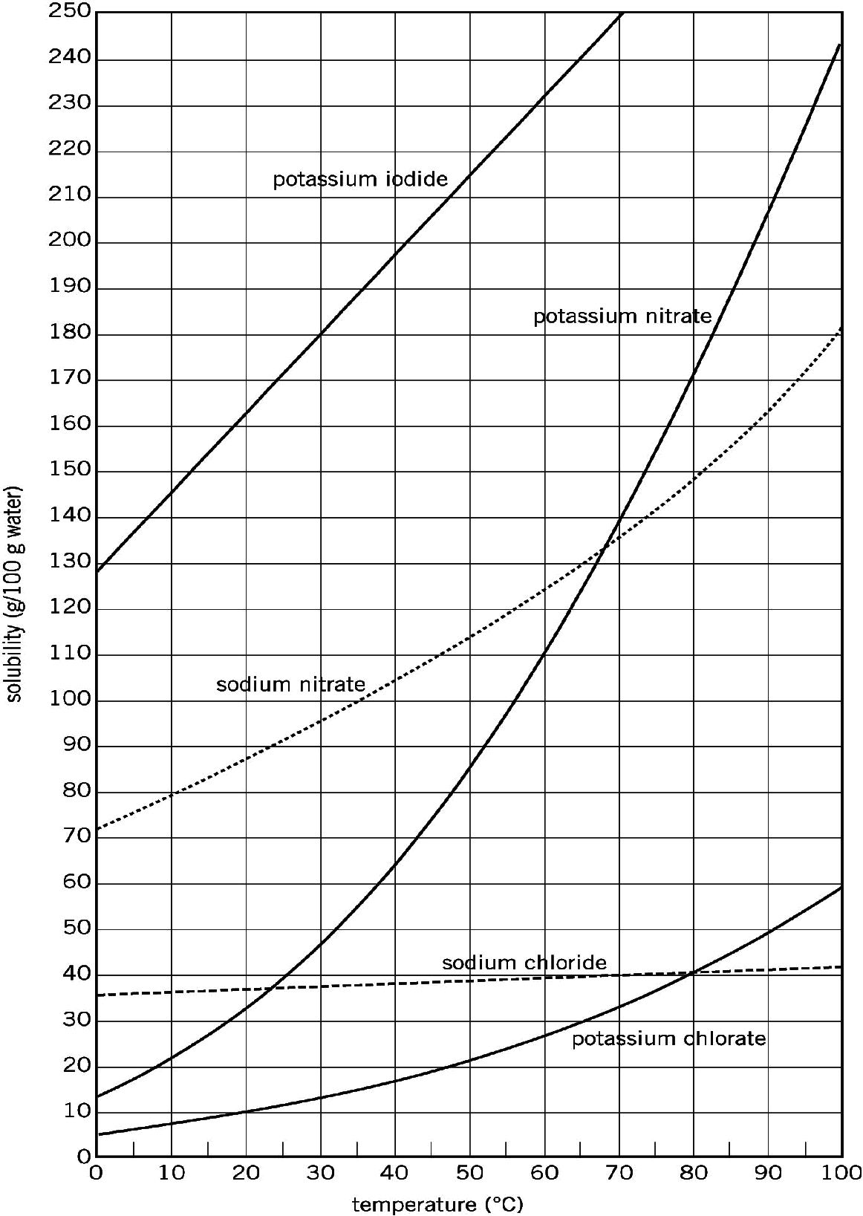

No. | Question | Answer
 | What is the solubility of sodium chloride at 75°C?
 | Which substance is the least soluble at 0°C?
 | Which substance is the most soluble at 70°C?
 | Which substance experiences the greatest change in solubility between 0°C and 30°C?
 | If a solution has 44 g of potassium nitrate dissolved in 100 g of water at 30°C, is it a saturated, unsaturated or supersaturated solution?
 | 300 g of potassium iodide is added to 100 g of water at 40°C. What mass of solid remains undissolved?
 | What mass of water would have to be added to the solution in question 6 in order to dissolve the remaining solid, assuming the temperature does not change?
 | A saturated solution is made by dissolving potassium nitrate in 50 g of water at 80°C. If this solution were to be cooled to 20°C, what mass of solid would crystallise out?
 | What mass of water needs to be added to 100 g of potassium iodide at 50°C to make a saturated solution?
 | 9.0 g of potassium chlorate is added to 60 g of water. At what minimum temperature would all the solid dissolve in the water?

